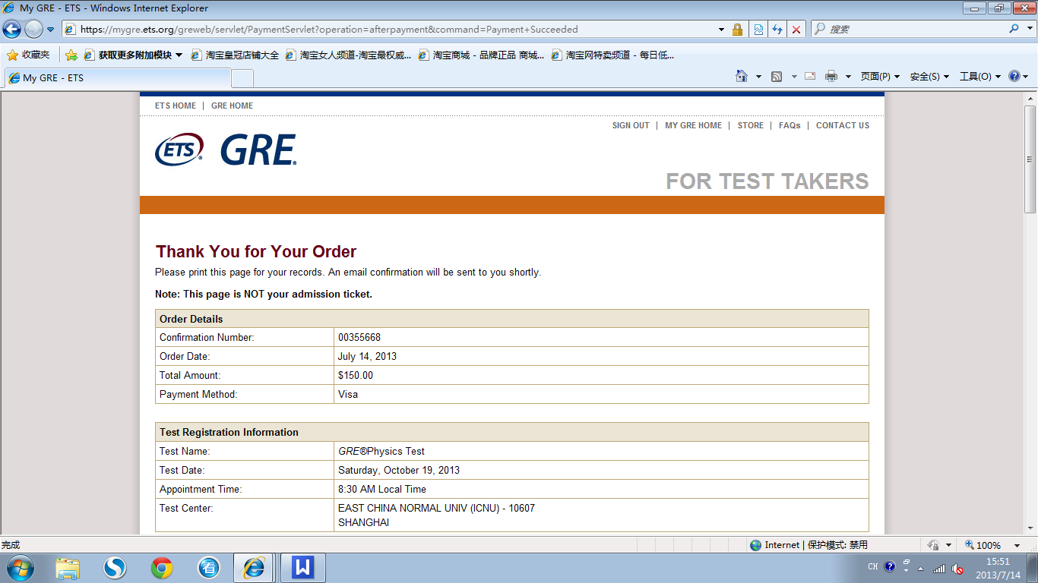

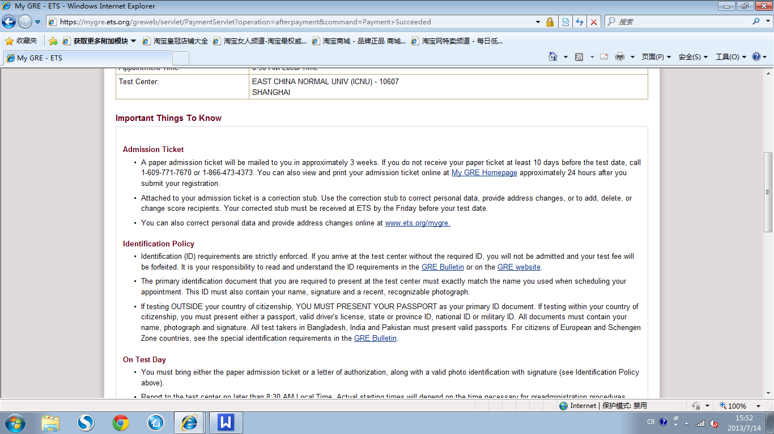

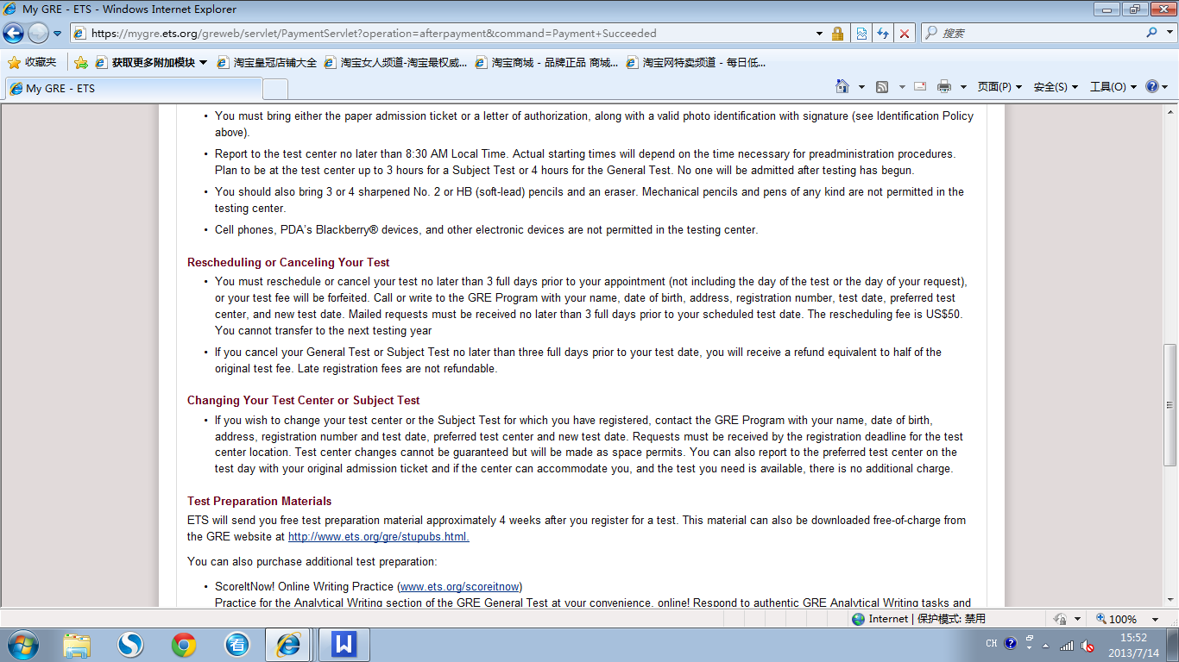

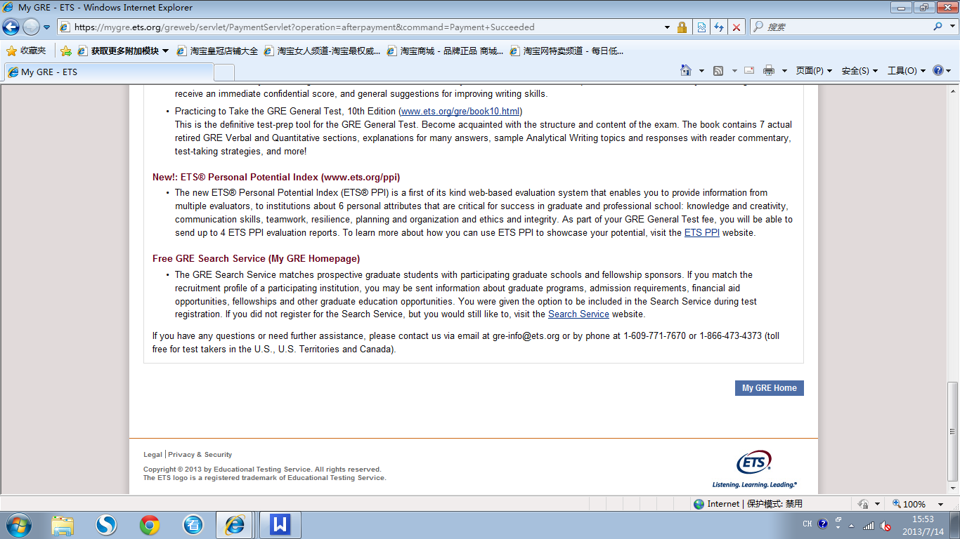

Thank You for Your Order
Please print this page for your records. An email confirmation will be sent to you shortly.
Note: This page is NOT your admission ticket.
Order Details
Confirmation Number: | 00355668
Order Date: | July 14, 2013
Total Amount: | $150.00
Payment Method: | Visa
Test Registration Information
Test Name: | GRE®Physics Test
Test Date: | Saturday, October 19, 2013
Appointment Time: | 8:30 AM Local Time
Test Center: | EAST CHINA NORMAL UNIV (ICNU) - 10607  SHANGHAI
Important Things To Know
Admission Ticket
- A paper admission ticket will be mailed to you in approximately 3 weeks. If you do not receive your paper ticket at least 10 days before the test date, call 1-609-771-7670 or 1-866-473-4373. You can also view and print your admission ticket online at My GRE Homepage approximately 24 hours after you submit your registration.
- Attached to your admission ticket is a correction stub. Use the correction stub to correct personal data, provide address changes, or to add, delete, or change score recipients. Your corrected stub must be received at ETS by the Friday before your test date.
- You can also correct personal data and provide address changes online at www.ets.org/mygre.
Identification Policy
- Identification (ID) requirements are strictly enforced. If you arrive at the test center without the required ID, you will not be admitted and your test fee will be forfeited. It is your responsibility to read and understand the ID requirements in the GRE Bulletin or on the GRE website.
- The primary identification document that you are required to present at the test center must exactly match the name you used when scheduling your appointment. This ID must also contain your name, signature and a recent, recognizable photograph.
- If testing OUTSIDE your country of citizenship, YOU MUST PRESENT YOUR PASSPORT as your primary ID document. If testing within your country of citizenship, you must present either a passport, valid driver's license, state or province ID, national ID or military ID. All documents must contain your name, photograph and signature. All test takers in Bangladesh, India and Pakistan must present valid passports. For citizens of European and Schengen Zone countries, see the special identification requirements in the GRE Bulletin.
On Test Day
- You must bring either the paper admission ticket or a letter of authorization, along with a valid photo identification with signature (see Identification Policy above).
- Report to the test center no later than 8:30 AM Local Time. Actual starting times will depend on the time necessary for preadministration procedures. Plan to be at the test center up to 3 hours for a Subject Test or 4 hours for the General Test. No one will be admitted after testing has begun.
- You should also bring 3 or 4 sharpened No. 2 or HB (soft-lead) pencils and an eraser. Mechanical pencils and pens of any kind are not permitted in the testing center.
- Cell phones, PDA’s Blackberry® devices, and other electronic devices are not permitted in the testing center.
Rescheduling or Canceling Your Test
- You must reschedule or cancel your test no later than 3 full days prior to your appointment (not including the day of the test or the day of your request), or your test fee will be forfeited. Call or write to the GRE Program with your name, date of birth, address, registration number, test date, preferred test center, and new test date. Mailed requests must be received no later than 3 full days prior to your scheduled test date. The rescheduling fee is US$50. You cannot transfer to the next testing year
- If you cancel your General Test or Subject Test no later than three full days prior to your test date, you will receive a refund equivalent to half of the original test fee. Late registration fees are not refundable.
Changing Your Test Center or Subject Test
- If you wish to change your test center or the Subject Test for which you have registered, contact the GRE Program with your name, date of birth, address, registration number and test date, preferred test center and new test date. Requests must be received by the registration deadline for the test center location. Test center changes cannot be guaranteed but will be made as space permits. You can also report to the preferred test center on the test day with your original admission ticket and if the center can accommodate you, and the test you need is available, there is no additional charge.
Test Preparation Materials
ETS will send you free test preparation material approximately 4 weeks after you register for a test. This material can also be downloaded free-of-charge from the GRE website at http://www.ets.org/gre/stupubs.html.
You can also purchase additional test preparation:
- ScoreItNow! Online Writing Practice (www.ets.org/scoreitnow)
Practice for the Analytical Writing section of the GRE General Test at your convenience, online! Respond to authentic GRE Analytical Writing tasks and receive an immediate confidential score, and general suggestions for improving writing skills.
- Practicing to Take the GRE General Test, 10th Edition (www.ets.org/gre/book10.html)
This is the definitive test-prep tool for the GRE General Test. Become acquainted with the structure and content of the exam. The book contains 7 actual retired GRE Verbal and Quantitative sections, explanations for many answers, sample Analytical Writing topics and responses with reader commentary, test-taking strategies, and more!
New!: ETS® Personal Potential Index (www.ets.org/ppi)
- The new ETS® Personal Potential Index (ETS® PPI) is a first of its kind web-based evaluation system that enables you to provide information from multiple evaluators, to institutions about 6 personal attributes that are critical for success in graduate and professional school: knowledge and creativity, communication skills, teamwork, resilience, planning and organization and ethics and integrity. As part of your GRE General Test fee, you will be able to send up to 4 ETS PPI evaluation reports. To learn more about how you can use ETS PPI to showcase your potential, visit the ETS PPI website.
Free GRE Search Service (My GRE Homepage)
- The GRE Search Service matches prospective graduate students with participating graduate schools and fellowship sponsors. If you match the recruitment profile of a participating institution, you may be sent information about graduate programs, admission requirements, financial aid opportunities, fellowships and other graduate education opportunities. You were given the option to be included in the Search Service during test registration. If you did not register for the Search Service, but you would still like to, visit the Search Service website.
If you have any questions or need further assistance, please contact us via email at gre-info@ets.org or by phone at 1-609-771-7670 or 1-866-473-4373 (toll free for test takers in the U.S., U.S. Territories and Canada).

Dear YUE PAN:
Your registration for the paper-based Graduate Record Examinations (GRE) Test is confirmed.
Please find the registration details below.
----------------------------------------------------------------------------------------------------------
ORDER DETAILS
----------------------------------------------------------------------------------------------------------
Confirmation Number: 00355668
Order Date: July 14, 2013
Total Amount: $150.00
Payment Method: Visa
----------------------------------------------------------------------------------------------------------
TEST REGISTRATION INFORMATION
----------------------------------------------------------------------------------------------------------
Test Name: Physics
Test Date: Saturday, October 19, 2013
Appointment Time: 8:30 AM Local Time
Test Center: 10607 - EAST CHINA NORMAL UNIV (ICNU),
SHANGHAI
----------------------------------------------------------------------------------------------------------
IMPORTANT THINGS TO KNOW:
----------------------------------------------------------------------------------------------------------
Admission Ticket
------------------------------------------
A paper admission ticket will be mailed to you in approximately 3 weeks. If you do not receive your
paper ticket at least 10 days before the test date, you can view and print your admission ticket online
at www.ets.org/mygre approximately 24 hours after you submit your registration or call GRE Services
at 1-609-771-7670 or 1-866-473-4373.
Attached to your admission ticket is a correction stub. Use the correction stub to correct personal
data, provide address changes, or to add, delete, or change score recipients. Your corrected stub must
be received at ETS by the Friday before your test date. You can also correct personal data and provide
address changes online at www.ets.org/mygre.
Identification Policy
------------------------------------------
Identification requirements are strictly enforced. If you arrive at the test center without the
required ID, you will not be admitted and your test fee will be forfeited. It is your responsibility
to read and understand the ID requirements in the GRE Bulletin or on the GRE website at
www.ets.org/gre/revised_general/test_day/id.
On Test Day
------------------------------------------
You must bring either the paper admission ticket or a letter of authorization, along with a valid
photo identification with signature(see Identification Policy above).
Report to the test center at least 30 minutes before your scheduled appointment for check-in procedures.
If you arrive late, you may not be admitted, and your test fee will be forfeited. Plan to be at the
test center approximately 5 hours.
You must bring a valid photo identification with signature (see Identification Policy above).
Cell phones, smartphones (e.g., BlackBerry(R), iPhone(R)), PDAs and other electronic or photographic
devices are not permitted in the testing center.
For further information see the GRE Information and Registration Bulletin.
You should also bring 3 or 4 sharpened No. 2 or HB pencils and an eraser. Mechanical pencils
and pens of any kind are not permitted in the testing center.
Rescheduling or Canceling Your Test
------------------------------------------
You must reschedule or cancel your test no later than 3 full days prior to your appointment
(not including the day of the test or the day of your request), or your test fee will be forfeited.
Call or write to the GRE Services with your name, date of birth, address, registration number, test date,
preferred test center, and new test date. Mailed requests must be received no later than 3 full days
prior to your scheduled test date. The rescheduling fee is US$50. You cannot transfer to the next
testing year.
If you cancel your General Test or Subject Test no later than three full days prior to your test date,
you will receive a refund equivalent to half of the original test fee. Late registration fees are not
refundable.
Changing Your Test Center or Subject Test
------------------------------------------
If you wish to change your test center or the Subject Test for which you have registered, contact GRE
Services with your name, date of birth, address, registration number and test date, preferred test
center and new test date. Requests must be received by the registration deadline for the test center
location. Test center changes cannot be guaranteed but will be made as space permits.
You can also report to the preferred test center on the test day with your original admission ticket
and if the center can accommodate you, and the test you need is available, there is no additional charge.
Test Preparation Materials
------------------------------------------
Individuals who register for the paper-based GRE revised General Test will be mailed a free copy of
The Practice Book for the Paper-based GRE(R) revised General Test. Individuals who register for a
Subject Test will be mailed a free practice book for the specific discipline. This free material
can also be downloaded at www.ets.org/gre/prepare and www.ets.org/gre/subject/prepare.
It can take up to four weeks to receive the test preparation material after you make your test
appointment or after your registration materials are received at ETS. Failure to receive the
test preparation material does not warrant a test refund or free test date transfer.
ETS(R) Personal Potential Index
------------------------------------------
The ETS Personal Potential Index (ETS(R) PPI) helps you show graduate and business schools a more
complete picture of your potential for success. It provides schools with more evidence of a broader
range of your capabilities - including knowledge and creativity, communication skills and teamwork -
than is captured in grades, test scores and recommendation letters. As a GRE(R) revised
General Test registrant, you can send four FREE ETS PPI Evaluation reports.
Visit www.ets.org/ppi and get started today.
If you have any questions or need further assistance, please contact GRE Services via email
at gre-info@ets.org or by phone at 1-609-771-7670 or 1-866-473-4373 (toll free for test takers in the U.S.,
U.S. Territories and Canada).
Sincerely,
GRE Services
--------------------------------------------
Be sure to add @ets.org to your address book or safe sender list to ensure that you receive email messages from ETS.
ETS does not send requests for credit card numbers, bank account numbers, or other sensitive financial information by email.
If you do receive a message of this type that appears to be from ETS, or related to an ETS product or service, please
do not respond. Send a copy of the message and any related details to contactets@ets.org.
Copyright 2013 by Educational Testing Service. All rights reserved. Rosedale Road. Princeton, NJ 08541. www.ets.org
--------------------------------------------------
This e-mail and any files transmitted with it may contain privileged or confidential information.
It is solely for use by the individual for whom it is intended, even if addressed incorrectly.
If you received this e-mail in error, please notify the sender; do not disclose, copy, distribute,
or take any action in reliance on the contents of this information; and delete it from
your system. Any other use of this e-mail is prohibited.
Thank you for your compliance.

GRE® Admission Ticket
- You must bring this admission ticket, along with acceptable and valid photo identification with signature, to be admitted to the test center.
- To correct your personal data, make address changes, or to add, delete, or change score recipients, please see the correction stub below. The completed stub must reach ETS by the Friday before the test date.

Test Registration Information
Test Name: | PHYSICS
Test Date | Saturday October 19, 2013
Reporting Time: | 8:30 AM Local Time
Test Center | EAST CHINA NORMAL UNIVERSITY - 10607  500 DONG CHUAN RD MINHANG DISTRICT  TEL:021.62545332  SHANGHAI, PR CHINA 200241

Personal Information
Name: | YUE PAN
Address | ROOM102,NO.88,TONGHE HOUSING  ESTATE,BAOSHAN DISTRICT,  SHANGHAI, 200431  CHINA
Seating Preference: | Right-handed seating

Important Messages
- USE VALID PASSPORT OR NAT'L ID WITH RECENT RECOGNIZABLE PHOTO & SIGNATURE. SEE BULLETIN
- * THIS TICKET HONORED ONLY ON TEST DATE INDICATED.
- * DUPLICATE OR REVISED TICKET. CHECK ALL INFORMATION CAREFULLY

